9-1 Project: Scenario 1: Process Summary

Marie-Chantal Foster
Cybersecurity, Southern New Hampshire University
CS-500-10018-M01 Introduction to Programming
Dr. Shadha Tabatabai
January 18, 2026

Process Summary - Financial Planner
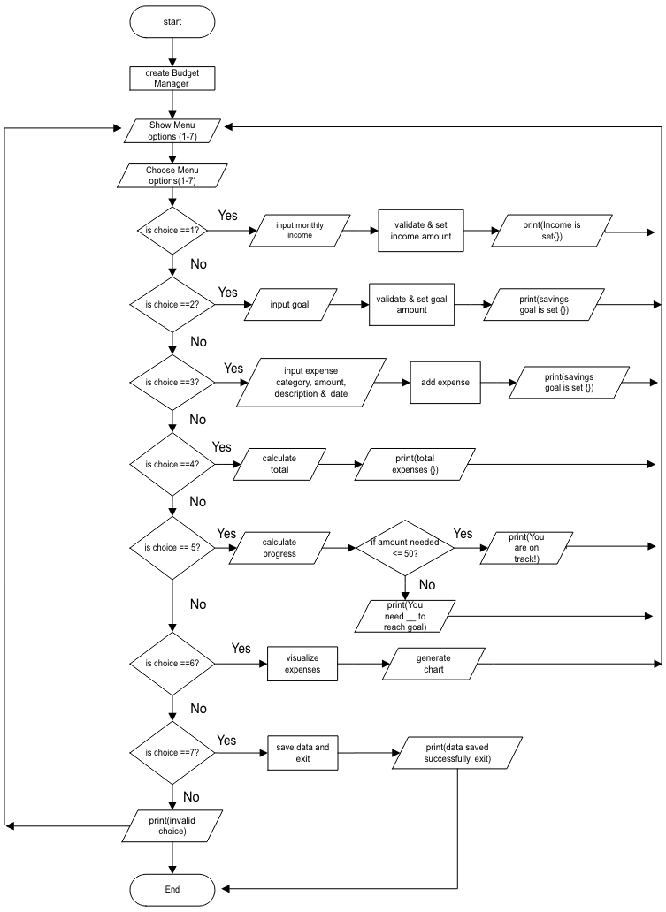
To apply my core programming skills, I chose to develop a financial application, which began with starter code in a program called Sense, which later morphed into an IDE to improve readability, functionality, and design. I thought the Financial Planner offered a practical way to apply my skills while aligning them with real-world responsibilities in software development. The project focuses on building user-friendly tools for a financial planning startup to help individuals manage their income and track expenses as they work toward a savings goal. Along with the program, I developed a flowchart (diagram shown) as a pre-coding tool to visualize the logic and structure of the Financial Planner program. This serves as a blueprint for the program. Throughout the development process, the project emphasizes best coding practices, secure input handling, and modular software design, which are essential skills for creating maintainable, professional-grade applications and strengthening an industry-ready portfolio.
Application of Object-Oriented Programming (OOP) Principles played a central role in the structure and functionality of my application, and it is widely used to develop budget-planning applications because its core principles closely mirror how people organize their finances. By targeting financial components as objects, developers can create software that is secure and easy to expand. I applied Encapsulation, Abstraction, Inheritance, and Polymorphism to create a modular, maintainable codebase. Encapsulation was implemented by organizing related data and behavior within dedicated classes. The Expense class stores and validates individual expenses, ensuring that each object protects its own state by rejecting invalid amounts or empty descriptions. The BudgetCategory class manages a collection of Expense objects and calculates category totals, while the BudgetManager class stores income, savings goals, and categories and coordinates higher-level operations. By keeping data and logic together, each class maintains responsibility for its own behavior, reducing dependencies and improving clarity. Abstraction was applied by exposing simple intuitive methods while hiding internal implementation details. For example, users interact with the system through methods like add_expense() or total_expenses() without needing to understand how expenses are stored, validated, or aggregated behind the scenes. This could also define methods like save_data() and load_data(). This separation allows the program to evolve internally without affecting how users interact with it. How Inheritance was used was to support testing and code reuse. I created a TestableBudgetManager class that inherits from BudgetManager and overrides the load_data() method. This allowed me to run unit tests without loading external files, demonstrating how inheritance can extend or modify behavior without rewriting entire classes. Polymorphism occurs through method overriding and the sharing of method names across classes. For example, BudgetManager and TestableBudgetManager implement a load_data() method, but each behaves directly depending on the object instance. Additionally, every category object responds to total_expenses(), enabling consistent behavior even if new category types are added in the future. Applying these core OOP prninciples creat a clean, modular architecture that is easy to maintain, extend, and test.
I organized the project into separate modules using Code Structure for Reusability and Maintainability, each with a clear, focused responsibility: financial.py contains the core business logic (Expense, BudgetCategory, BudgetManager, and the main program), while storage.py handles JSON persistence and file handling. Then test/test_financial.py handles the automated unit tests. The structure promotes reusability across the Classes for future features such as a GUI, an API, or a reporting system. Maintainability will help if data storage requirements change; only storage.py needs to be updated. As for the Separation of concerns, each file handles a single major responsibility, reducing complexity and improving readability. This modular approach was guided by the tutor on how to mirror professional software engineering practices and ensure that an application can grow without becoming difficult to manage.
Throughout the project, I followed Python’s recommended Coding Standards and Readability Principles, including PEP 8 naming conventions for function names (add_expense) and class names (BudgetManager). 2. To improve readability, I used clear, descriptive variable names. 3. Comments where clarification was needed. 4. Consistent indentations by using four spaces with no tabs and spacing. Avoided extraneous whitespace and maximum line length such as 79 characters for code and 72 for docstrings. 5. When importing, make sure it is in the order of library, party, and local application. 6. Consistent with string quotes, whether I use single or double, I stuck with one throughout the project. 7. Logical grouping of methods within classes, such as clear grouping: create expense to store to calculator totals. 8. Short focus functions to avoid unnecessary complexity by having one lien and one responsibility, making them easy to test and read. For example, on one line: def total_expense(self) -> float:, then next line with four indentations: return sum(e.amount for e in self.expense). 9. Refactoring the JSON persistence logic into storage.py significaitly imported readability and maintainability by removing file-handling clutter from the main business logic.
Several Python built-in Libraries and External Packages were used to enhance functionality and reduce complexity. JSON for saving and loading persistent data. Unit tests for automated testing. Datetime for validating date formats and matplotlib for generating visual expense charts, which the tutor brought to my attention, is to be used in a virtual environment (venv). This would isolate dependencies so each project gets its own environment and doesn’t affect other projects, and I could run my tests in a controlled environment for more reliable testing, especially with TestableBudgetManager. These libraries allowed me to implement robust features without reinventing common functionality, making the program more efficient and professional.
Security and data integrity are important considerations in code development. The several Secure Coding Practices I applied are Input validation to reject negative amounts, empty descriptions, and invalid dates. Type-checking to ensure numerical values are properly formatted. Validation inside the Expense class to prevent corrupted or unsafe data from being created. Error handling for JSON operations to protect against missing files, corrupted data, or invalid structures. And avoidance of over- or under-logic by validating numerical input before processing. These were best practices to help prevent common vulnerabilities and ensure the application behaves safely even when unexpected input is entered.
Error-handling mechanisms and Program Reliability features were implemented using try/except blocks for file operations. ValueError exceptions for invalid expenses. Graceful fallback behavior when no data file exists, and User-friendly error messages during input validation, such as “Invalid input. Please enter a positive number or an Invalid date format. Please enter date in YYYY-MM-DD.” These constructs ensure the program does not crash due to invalid input or missing files. Instead, it guides the user to resolve the issue to improve overall stability and user experience, rather than terminating unexpectedly. Giving your program a controlled flow is part of its robustness strategy.
The Testing methodology, including unit tests, played a major role in validating the program’s functionality. I created a suite of unittests that covered the behavior of the Core class behavior (Expense, BudgetCategory, and BudgetManager). Edge cases, such as negative expenses: Test checks my system rejects invalid financial data. Integration-style tests: Verifies that multiple parts of my system work together correctly, such as set income, added expenses, and progress_toward_goal(), and expected the result to reflect the correct savings calculation. Automatic category creation: The system automatically creates a category if it doesn’t exist. Validation of invalid data: Tests confirm the logic; Expense validation inside the Expense class, and a TestableBudgetManager class to isolate tests from file I/O, avoiding loading JSON files during tests. These test suites confirmed that all requirements were met and the program behaved correctly under various conditions. Below are a few screenshots of some of the tests that were conducted from the list above:
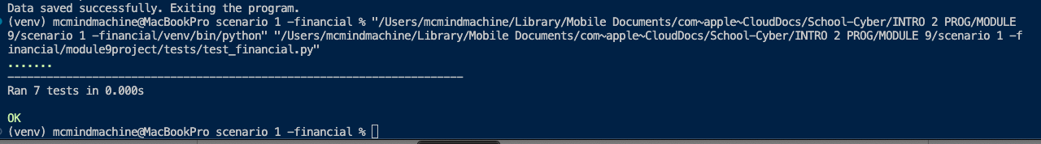
1) Unit testing and Validation of requirements. Confirms all tests passed, meets the functional and technical requirements, and that the TestableBudgetManager setup works correctly, thereby ensuring the integration logic behaves as expected.
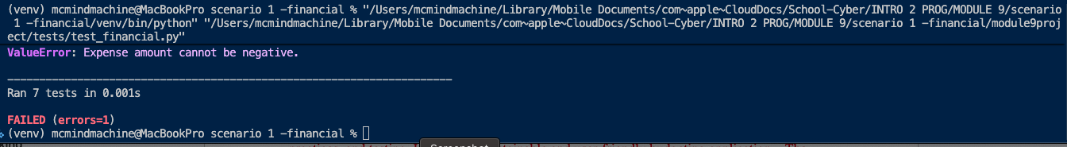
2) Edge cases and Validation of invalid data. Show the test suite checks for rejected negative expenses. A ValueError was raised but not caught reviling secure coding validation at work and helping identify logic issues before deployment
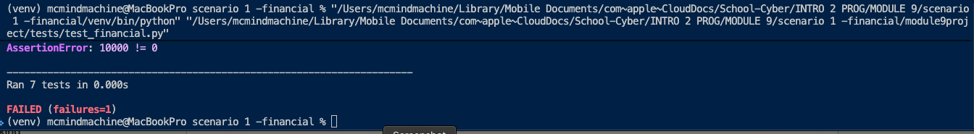
3) Integration-style testing. The components’ failed interaction didn’t behave as expected.
In conclusion, the project allowed me to apply core programming skills in a realistic, professional context. By using object-oriented design, modular architecture, secure coding practices, and testing, I created a maintainable and user-friendly budgeting application. The experience strengthened my understanding of software engineering principles and provide strong foundation for building a future career in a professional environment.

References

